1. 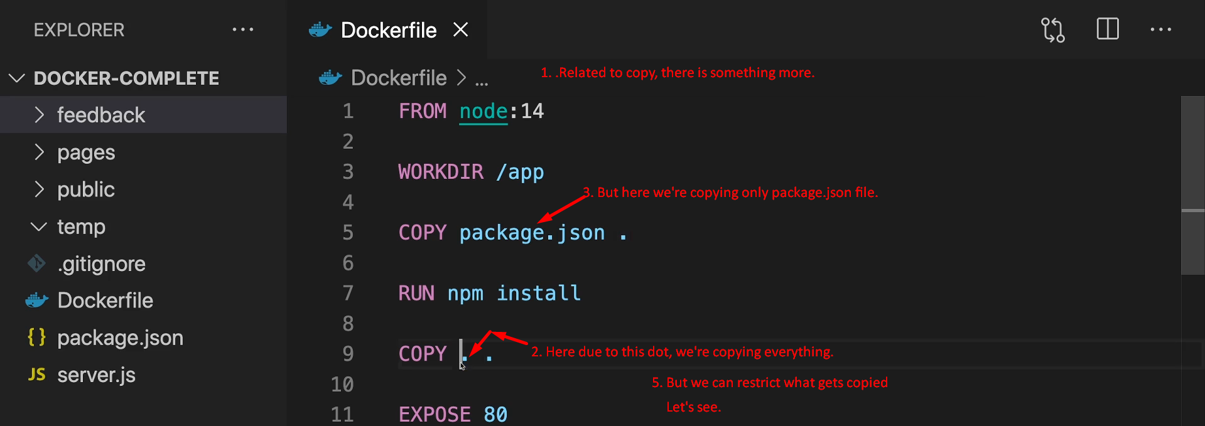
2. By adding **.dockerignore**, we can control what files and folders should not be copied when using “copy . .”.  
   This concept is similar to **.gitignore**.
3. 